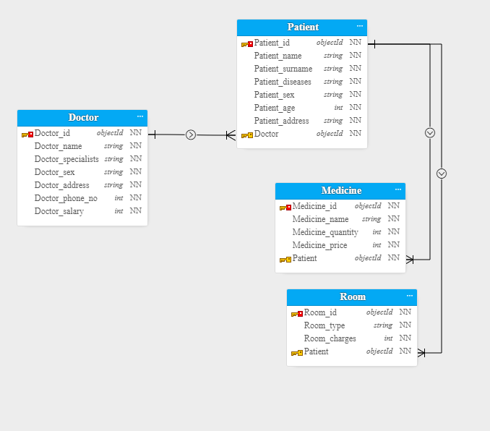

Doctors

create table doctor (doctor_id int, doctor_name varchar2(30),doctor_specialization varchar2(30),

doctor_sex varchar2(30),doctor_address varchar2(20),doctor_number int,doctor_salary int, Constraint doctor_id primary key (Doctor_id));

create table patient(patient_id int, patient_name varchar2(30),

patient_surname varchar2(30),patient_disease varchar2(30), patient_sex VARCHAR2(6),patient_age int,

patient_address varchar2(50), Doctor_id int,constraint patient_id_pk primary key(patient_id),

Constraint patient_doctor_fk foreign key(doctor_id)

REFERENCES Doctor(Doctor_id));

create table Medicine(Medicine_id int , Medicine_name varchar2(20), Medicine_quantity int,Medicine_price int,patient_id int ,constraint Medicine_id_pk primary key(Medicine_id),

constraint Medicine_Patient_fk foreign key (Patient_id) references Patient(Patient_id));

create table room(room_id int,room_type varchar2(20),room_charges int ,patient_id int ,constraint room_id_pk primary key(room_id),

constraint room_Patient_fk foreign key (Patient_id) references Patient(Patient_id));

**HOSPITAL PROJECT**

User

Create table user_account(User_Name varchar2(50), user_password varchar2(50))

Insert into user_account(User_name, User_password)

Values('Noor','noor')

**DOCTORS DATA**

insert into doctor(doctor_id, doctor_name, doctor_specialization, doctor_sex, doctor_address,doctor_number,doctor_salary)

values (10, 'Dr.Hafeez', 'Gastroenterologists', 'Male','Lums jamshoro', 0212345, 80000);

values (20, 'Dr.Iram', 'Internists', 'Female','Chandka Larkana', 0219901, 60000);

values (30, 'Dr.Salar', 'endocrinologists', 'Male','jinnah Karachi', 0217768, 90000);

values (40, 'Dr.Umar', 'Hematologists', 'Male','Dow Karachi', 2170875,100000 );

values (50, 'Dr.Saima', 'Neurologists', 'Female','Agha Khan Karachi', 02130655, 200000);

insert into patient (patient_id,patient_name,patient_surname,patient_disease,patient_sex,patient_age,patient_address,doctor_id)

values(101,'Saad','Samo','liver problem','Male',25,'Jamshoro Sindh',10);

values(102,'Zain','Baloch','Stomach','Female',27,'Larkana Sindh',20);

values(103,'Uzma','Shah','Blood spleen','Female',29,'Karachi Sindh',30);

values(104,'Ali Raza','Jatoi','Cancer','Male',32,'Karachi Sindh',40);

values(105,'Shazaib','Memon','Diabaties','Male',24,'Hydrabad',50);

insert into medicine (medicine_id,medicine_name,medicine_quantity,medicine_price,patient_id)

values (1201,'Vee Liver,Livo Tab',4,1400,101);

values (1202,'NSAIDS,OPIOID',12,2200,102);

values (1203,'Spleen Support',14,900,103);

values (1204,'Nexum Tab',17,700,104);

values (1205,'Carcifin Mini Tab ',22,3300,105);

insert into room (room_id, room_type, room_charges, patient_id)

values (3101,'Private Ward',1200,101);

values (3102,'Semi Private Room',2600,102);

values (3103,'Private Room',5000,103);

values (3104,'Private Plus Room',8000,104);

values (3105,'Executive Room',11000,105);